Component maths

R4 – current limiting base transistor

2K4 Ω

The relay has a coil resistance of 70Ω. So the current draw will be

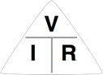

I = V ÷ R

0.07A = 5v ÷ 70Ω

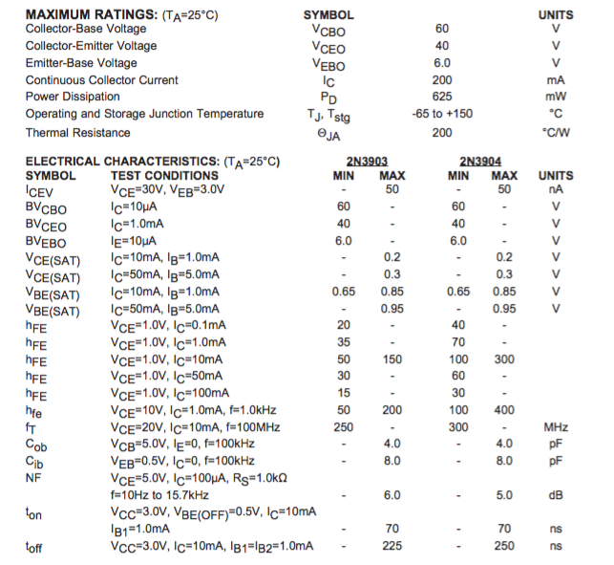

2N3904 datasheet

|  |  |  |  |  |  |
| --- | --- | --- | --- | --- | --- |
| Calculate the base resistor | | |  |  |  |
| Supply HFE,VIN,VBE from the datasheet and your IC from your circuit | | | | | |
|  | A | mA | uA |  |  |
| IC | 0.07 | 70 | 70000 |  |  |
| HFE | 45 |  |  |  |  |
| IB | 0.001555556 | 1.555555556 | 1555.555556 |  |  |
|  |  |  |  |  |  |
| VIN | 5 |  |  |  |  |
| VBE | 0.95 |  |  |  |  |
| RB | 2603.571429 |  |  |  |  |

Transistor base current

IB = = = 1.5mA

Transistor Base resistance

RB = = = 2603Ω

Closest standard value resistor 2K4Ω

Reference:

http://www.electronics-tutorials.ws/transistor/tran_4.html

------------

R3 – current limiting led

I didn’t base these values from a datasheet. I used common values.

|  |  |  |  |  |
| --- | --- | --- | --- | --- |
| Calculate series resistor | |  |  |  |
| Supply VF,IF from the led datasheet and VS for your circuit | | | | |
|  |  |  |  |  |
|  |  | mA |  |  |
| VS | 5 |  |  |  |
| VF | 1.8 |  |  |  |
| IF | 0.014 | 14 |  |  |
| RS | 228.5714286 |  |  |  |

Reference:

<http://www.electronics-tutorials.ws/diode/diode_8.html>

R1 – pull up reset button

In the atmega328 datasheet it says

24.3 Physical Interface

Pull-up resistors on the dW/(RESET) line must not be smaller than 10kΩ.

R2 – pull up prog button

Copied from R1, if it works for the reset it will work for any other button.

C4/C5 power regulator caps

0.33uF – taken from the example in the datasheet. Note the datasheet recommends

A 0.33 mF or larger tantalum, mylar, or other capacitor having low internal impedance at high frequencies should be chosen.

I ignored that advise and used the multilayer ceramic caps. I did that because the regulator datasheet says they are optional; so adding them in is probably better than not having them.

But tantulum are crazy expensive

C7/C6 decoupling caps

A normal decouping cap is 0.1uF or 0.01uF, I have used 0.1uF.

Sparkfun have a good description of decoupling caps here: <https://learn.sparkfun.com/tutorials/capacitors/application-examples>

C2/C1 crystal

I choose 20pF using a Cstray value of 10pF because I don’t have a clue and the crystal is a little distance from the uC.

Reference: <https://blog.adafruit.com/2012/01/24/choosing-the-right-crystal-and-caps-for-your-design/>

D1 – diode reverse power protection

1N4004

could have used 1N4001 and it would work just the same. But I choose a 400V protection because I need a coil flyback diode. So I reused the same diode here.

D2 – diode flyback relay

Provided 400V reverse DC blocking voltage. Because the relay is a coil I wanted to be extra sure. I think a 1N4001 would also work just as well.

RELAY – the relay

Chosen because I wanted a small size relay. It provided 10A rating which is plenty good enough for a garage door opener. It works on upto VAC 227, and upto 28VDC. So it has a good overall usage,